1. GitHub
https://github.com/K4m1G1r1/Eien-System-Kizuna
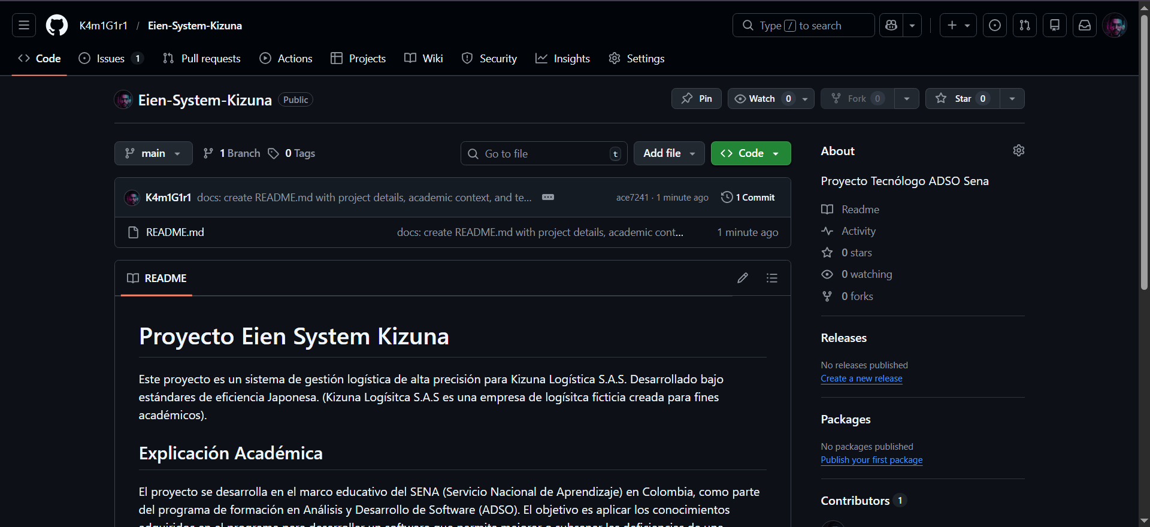

2. Slack
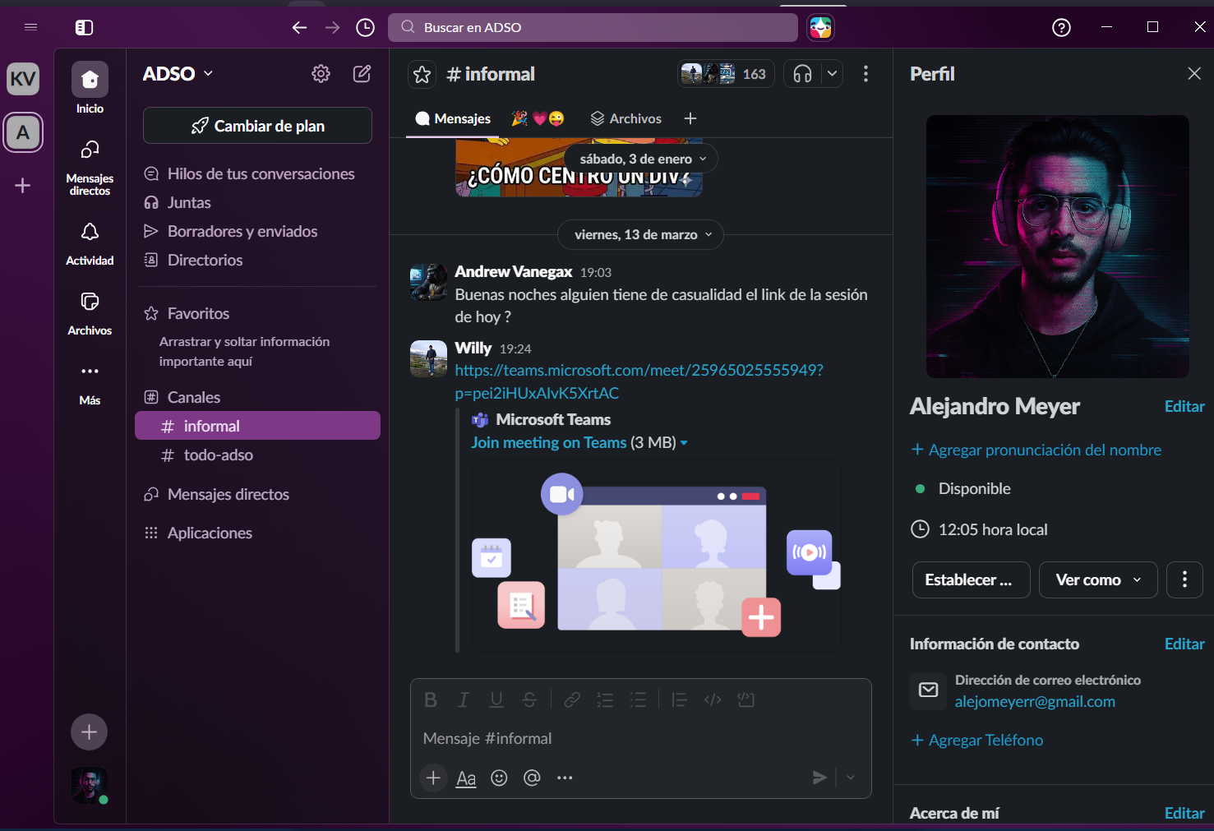

3. Trello
https://trello.com/b/ZOBiqOWh/eien-system-development
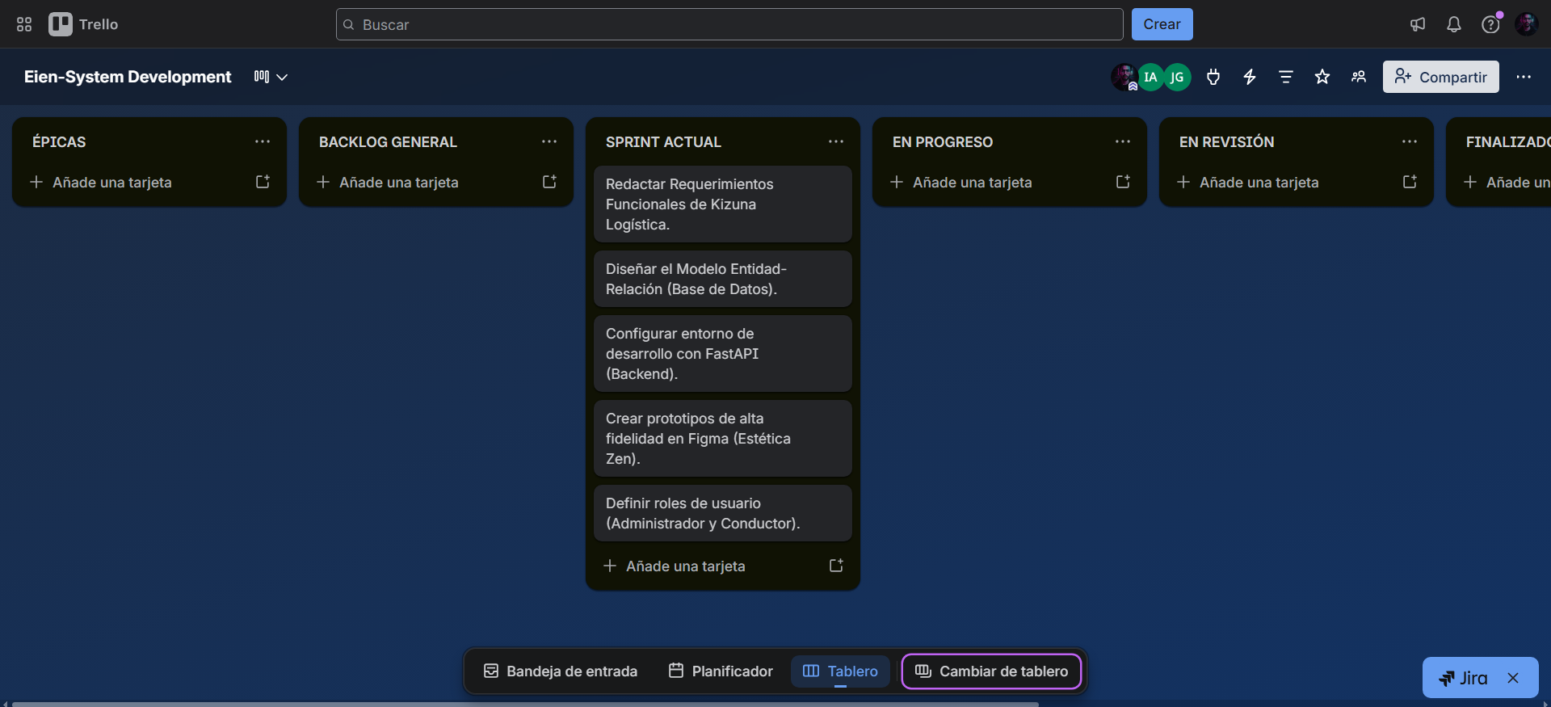
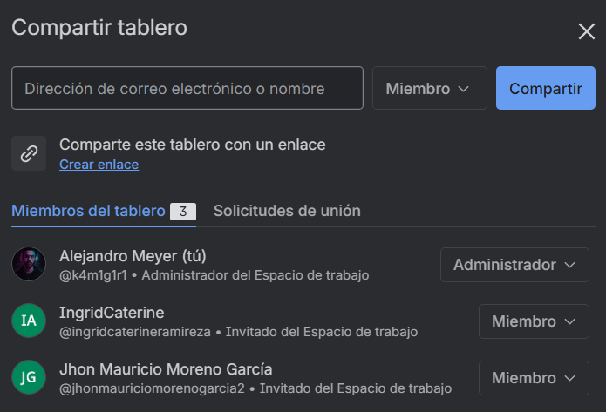

4. Google Drive
https://drive.google.com/drive/folders/1jPhEv6qXHbbsPNRJMr3XFGTuOmkvi2zL?usp=drive_link
